## Task 1: Launching an EC2 Instance

1. Make sure you are in US East (N. Virginia) us-east-1 Region.
2. Navigate to EC2 by clicking on the  menu in the top, then click on EC2 in the Compute section.
3. Navigate to Instances on the left panel and click on 
4. Enter name as *MySpotInstance*
5. Choose an Amazon Machine Image (AMI): Search for Amazon Linux 2 AMI in the search box and click on the select button.

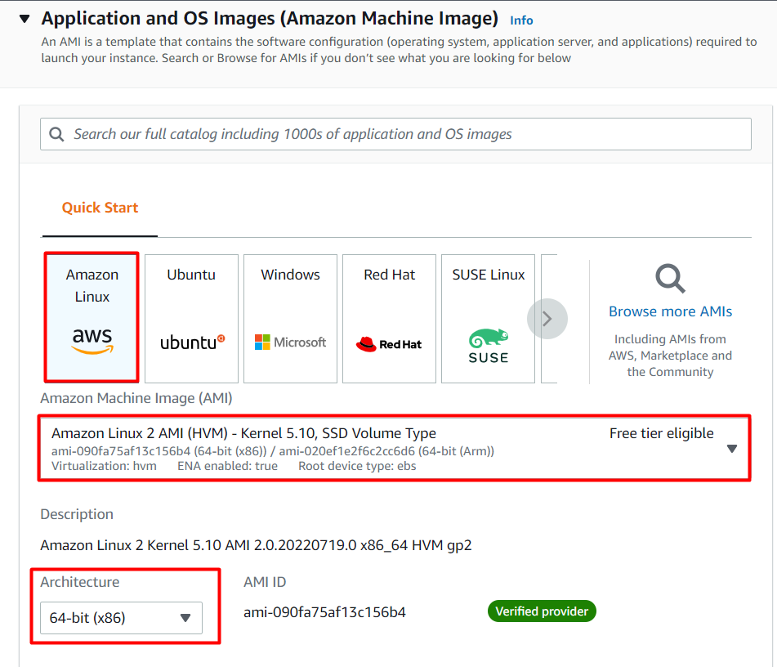

1. Choose an Instance Type: Select *t2.micro*

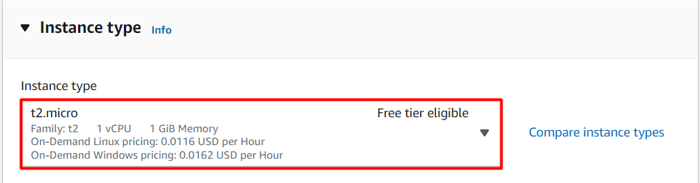

7. For Key pair : Choose Create a new key pair.

* Key Pair name : Enter MySpotKey
* Key pair type : Choose RSA.
* Private key file format: Choose .pem

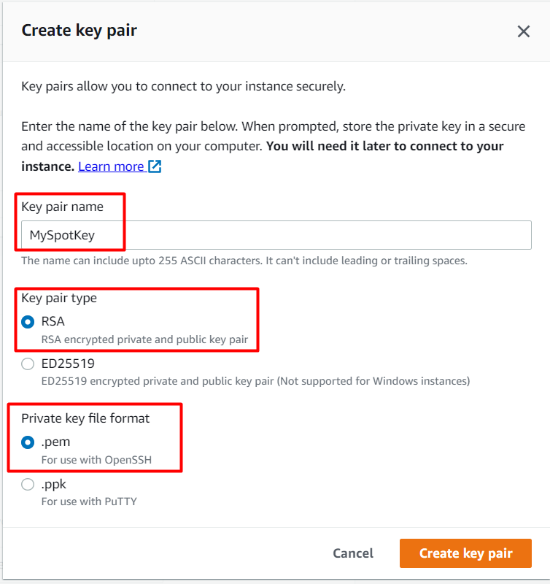

8. Under Network Settings ,

* Choose Create security group.
* Check the Allow SSH traffic from.
* Check the Allow HTTP trafic from.

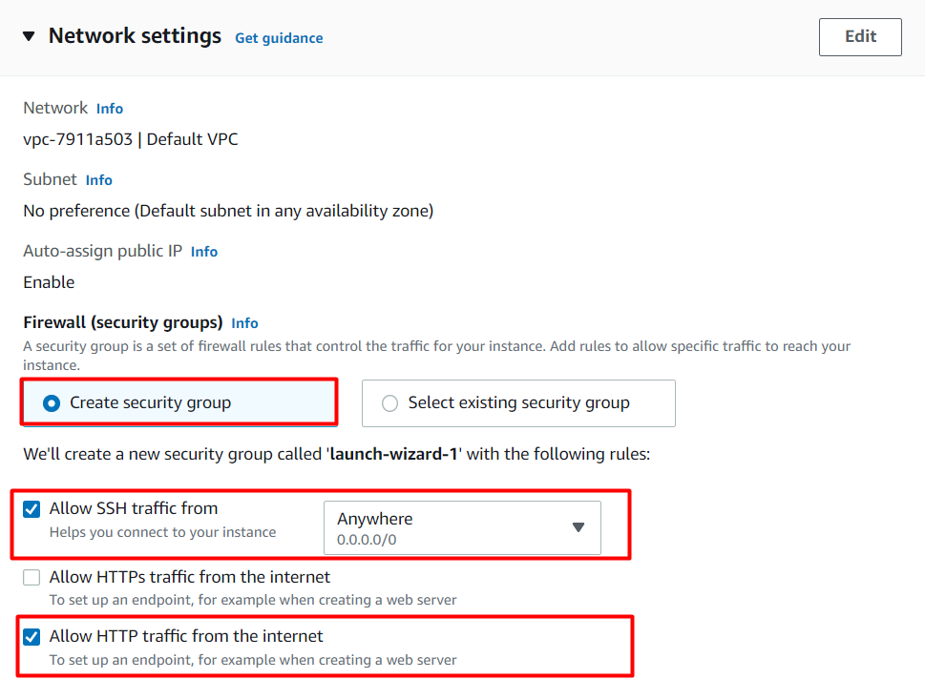

9. Under Advanced Details,

* Purchasing option: Check the Request Spot instance option
* Click on *Customize.*

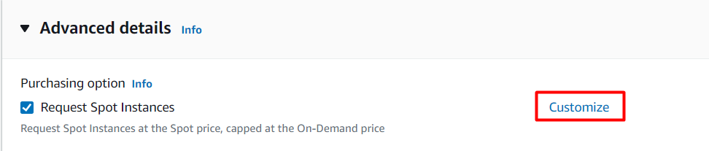

* Maximum price : Choose Set your maximum price(per instance/hour)
* Set $0.003 as the price.
* Request Type : Choose One-time
* Valid to : Choose No request expiry date.

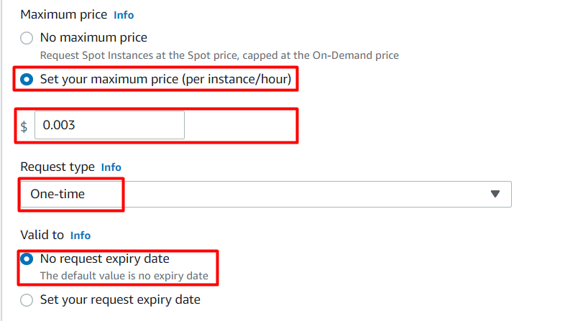

* Persistent request: we will not choose the option, but you should know what that means. Below is the explanation  
  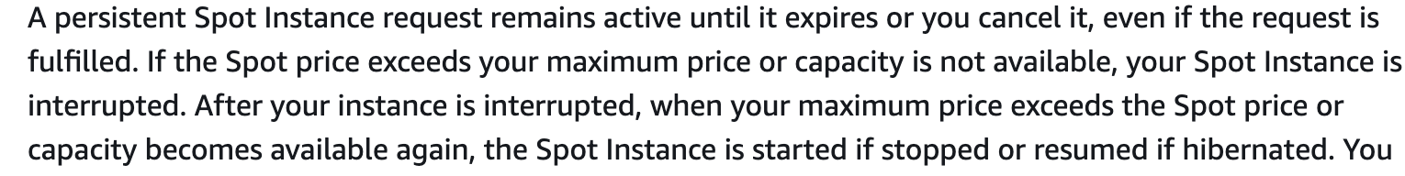

10. Under the User data section, enter the following script, (which creates an HTML page served by Apache)

| #!/bin/bash  sudo su  yum update -y  yum install httpd -y  echo "<html><h1> Welcome to Whizlabs Server</h1><html>" >> /var/www/html/index.html  systemctl start httpd  systemctl enable httpd |
| --- |

11. You will get an error message like this if your Maximum price was less than the Current price shown in the Availability zone and Current Price table.  
 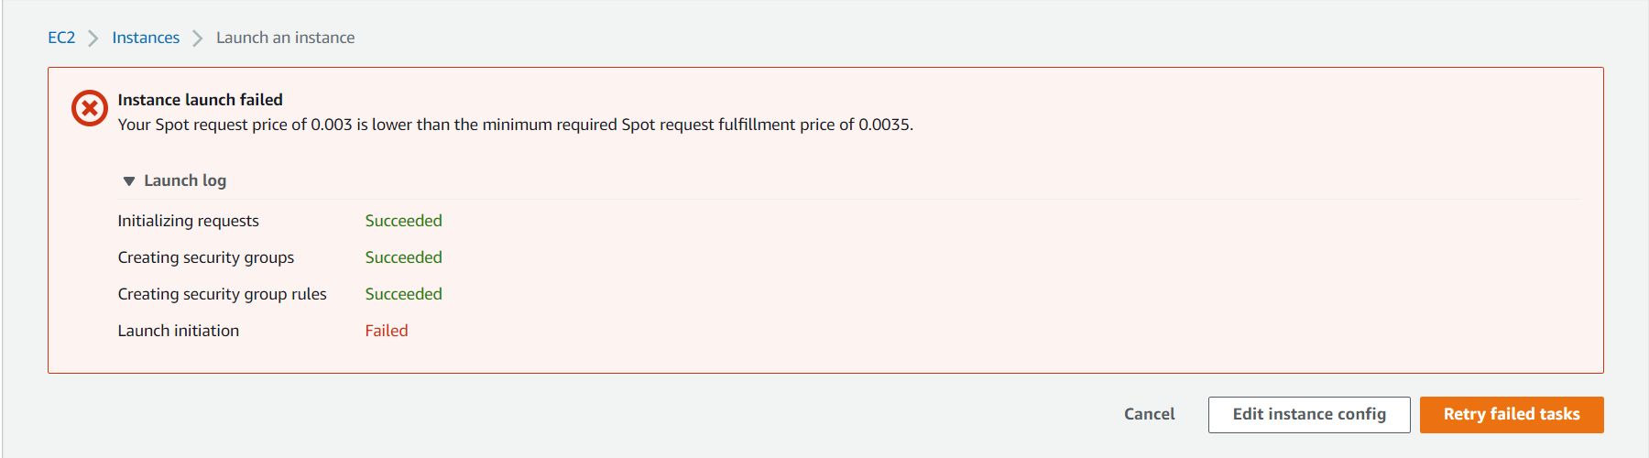

12. Now Click on Edit instance config and Edit the maximum Price, set to 0.01, and then click on Review and Launch  
 Note: If by mistake you clicked on the *Cancel* button, you have to repeat from Step 4.

13. Click on Launch Instances button.

14. Launch Status: Your instances are now launching, Navigate to Instances page from left menu and wait the status of the EC2 Instance changes to running and health check status changes to  .  
  
 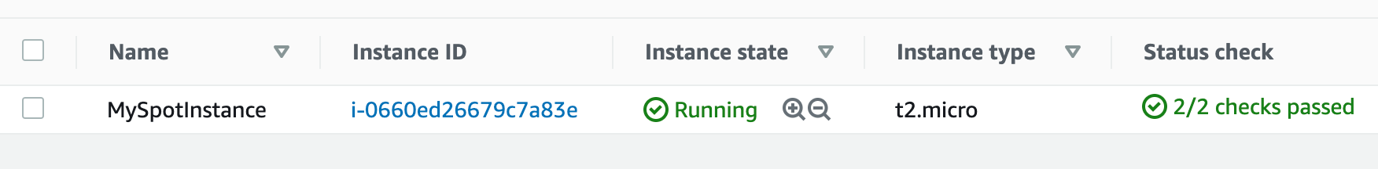

15. To test if the HTML page is published, copy the Public IPv4 Address of your EC2 Instance and run it on the browser.

16. Make sure the URL Protocol is http not https.

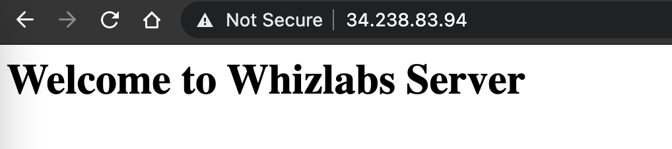

Task 3: View the Spot Request

1. Click on Spot Requests in the left sidebar, you will see the Spot requests.



2. Click on the Request ID, to see more details about your spot request.

* Max price: The highest price you are willing to pay for this EC2 Instance.
* Instance Id: Your current EC2 Instance, associated with this Spot request.
* Interruption: Terminate, if the current price of this Spot Instance goes higher than the original price, then it will be terminated automatically.
* Availability Zone: Current Price of the Spot instance varies by Availability Zone, There might be a possibility that in other AZ’ you can get the same instance at a lower price.

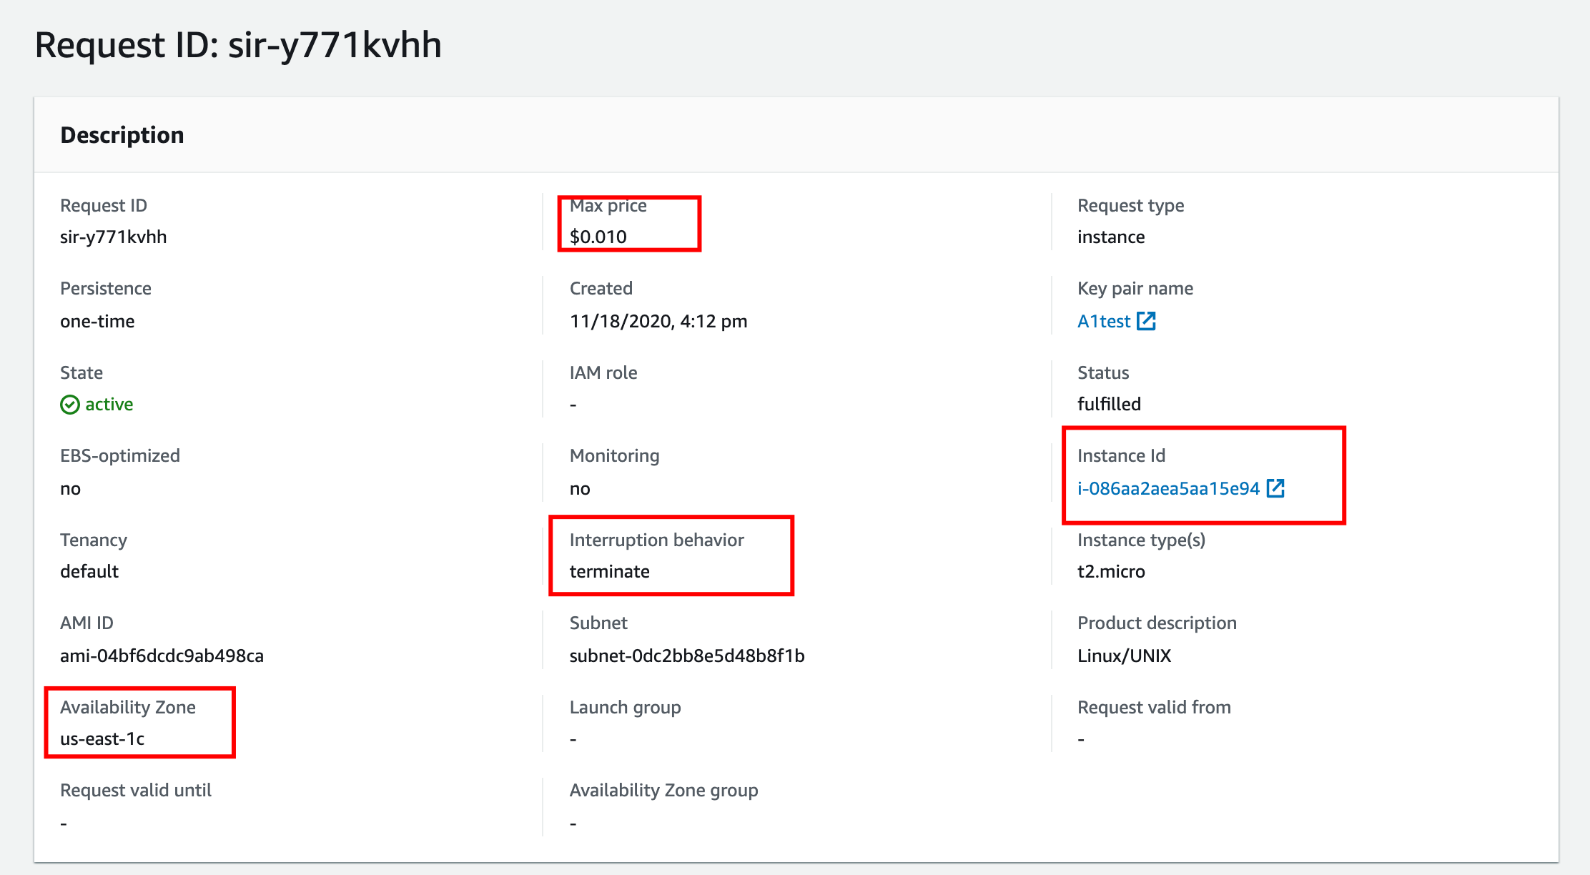

Task 4: Explore the Saving Summary and Pricing history

1. Click on the Spot Requests in the Left sidebar and you will see the Spot requests.

2. On the right top corner, you will see two buttons named Saving summary and Pricing history, Let’s explore those options too.

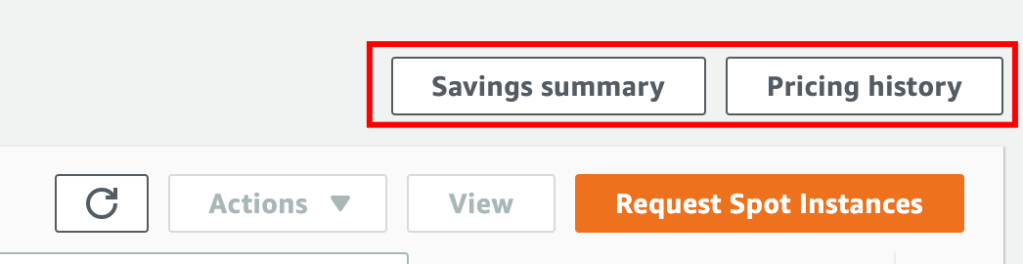

3. Click on the Saving summary, below you can see, you will save a total of 70% as compared to on-demand instances. Details are also available.

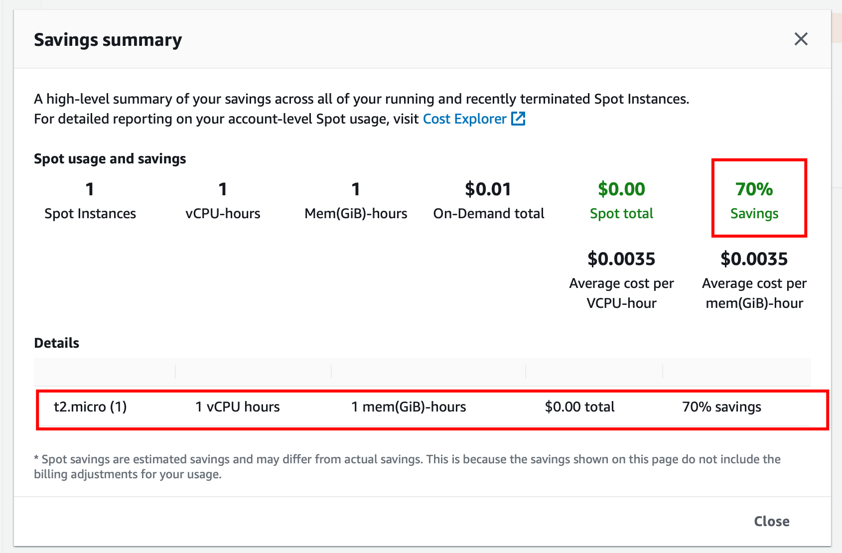

4. Click on the Close button, and let’s explore the Pricing history option.

5. Here you will see the pricing history, but wait a minute, it’s showing for some other Instance size, let’s modify the options.

* Graph: Availability Zones
* Instance type: Enter t2.micro
* Platform: Linux/UNIX
* Date Range: Select 3 months

